**Tharun Bejawada (191911509)**

**8.AIRLINE RESERVATION SYSTEM UML DIAGRAMS**

**1.USE CASE DIAGRAM**

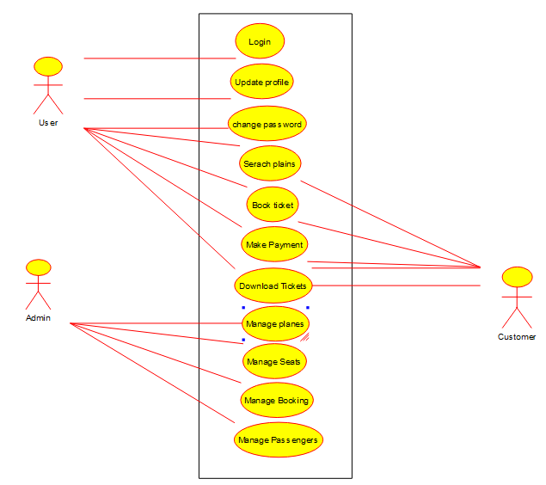

**2.SEQUENCE DIAGRAM**

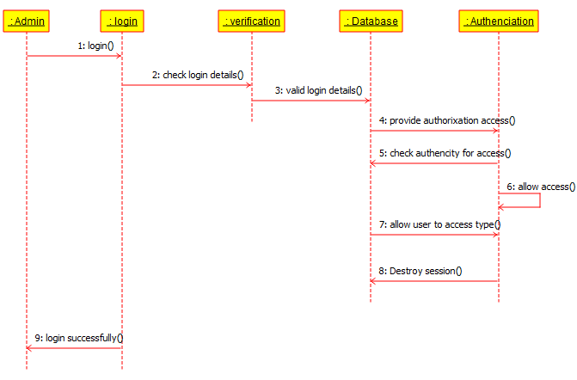

**3.CLASS DIAGRAM**

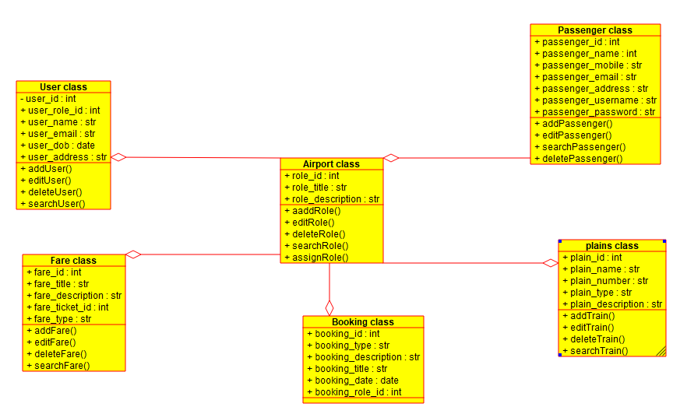

**4.STATE DIAGRAM**

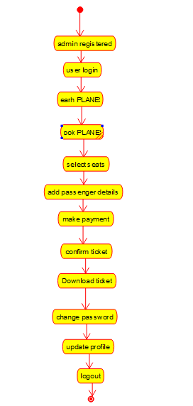

**5.ACTIVITY DIAGRAM**

